2" ATS Set-Up Instructions

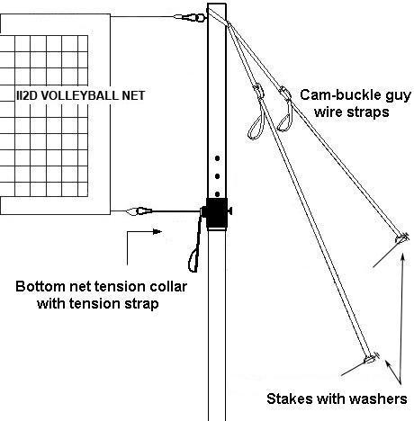
POLES SET UP

First, take your poles apart by sliding the inner pole out of the outer pole. Take your two hardware collars, slide them over the outer pole, and fit them flush with the bottom of the pole so the eyebolt or cam buckle is facing the same way as the large eyebolt at the top of your pole. Loosen and tighten your collar by turning the knob on the outside of the collar. The bolt on the cam buckle collar holding the cam buckle onto the collar should be on top or above the cam buckle so the buckle lays flat against the collar. Once the collars are on, slide your inner pole back into the outer pole.

ATTACHING NET TO POLES

Steel Cable Nets
You will attach the top of your net to your poles first. One side of your steel cable will have a factory made loop. Use the supplied cable clamps to secure a loop in the steel cable at the other end of the net. Connect your net to your poles one foot from the pole to the edge of your net. Use supplied carabineer clips to attach the steel cable to eyebolts on your poles. (Note that the top and bottom ropes/cables will slide throughout the net like a drawstring in a pair of pants.)

Rope Cable Nets
You will attach the top of your net to your poles first. Tie a slipknot to make loops on each side of your net. Connect your net to your poles one foot from the pole to the edge of your net. Use carabineer clips to attach rope cable to eye loops on poles. (Note that the top and bottom ropes/cables will slide throughout the net like a drawstring in a pair of pants.)

NET TENSION
Slide the stakes and washers through the d-rings on the guy wires and pound each stake into the ground at a 45-degree angle approximately 4-5 feet away from the pole and court. See the picture above for a visual description. (Caution: Stakes must be driven all the way down into the ground with only the head of the stake and the D-ring showing above the ground.)

Extend the pole and secure in place using the push button to lock the pole at one of the heights. Find the loop on each guy wire that is fixed to the cam-buckle and does not adjust. Slide that loop over the top of the pole (two per side); the webbing will rest on the large eyebolt on the inside of your pole. Stand your pole up and angle it towards the center of the court. Repeat this process for the other pole. Once your poles are up, apply tension to top of the net by pulling downwards on the adjustable strap on the red guy wire. Then adjust your poles to a vertical position.

To tension the bottom, connect the rope/cable of the net to the eyebolt collar with the provided carabineer about a foot away from your pole. On the other side, make a loop right next to where the rope/cable comes out of the net. Connect that to the carabineer on the cam buckle collar. Now, pull down on the bottom black webbing tension strap to tighten the lower rope/cable. (Don’t pull too hard on the black strap. If your pole bends, it will not telescope properly.)

The last thing to do is apply tension to your net’s side tension ropes. This is an optional step and most of the time you do not need to use these ropes unless it is quite windy outside or you want to keep your net tighter or centered the middle of your court. You simply tie the ropes around the backside of the pole and back to themselves.

For storage, release the tension on your guy wires and roll them up onto the orange plastic hand winder. Press the push button and collapse the two-piece pole together. The net and tie cords can be left on and rolled up onto the poles. After use on sand we recommend that you take the poles apart and hose them down with clean water to remove sand and dirt before telescoping them together. This helps with the scratching of your poles and keeps them from getting stuck in the down or up positions.
Store system in cool dry place and do not expose to prolonged periods in the sun, or rain. Store on a flat surface away from heat source. For set up at the beach, try to keep the sand out of the telescoping pole. Try not to the let poles fall onto sand during set up or take down. If this occurs you can hose them out with fresh water at home to remove all sand from inside and outside of the tubes, or submerge in the water and try to separate them. Let them dry in a vertical position before telescoping together. (If you have any questions about set up, feel free to call 800-494-3933)

How to tie a loop knot.

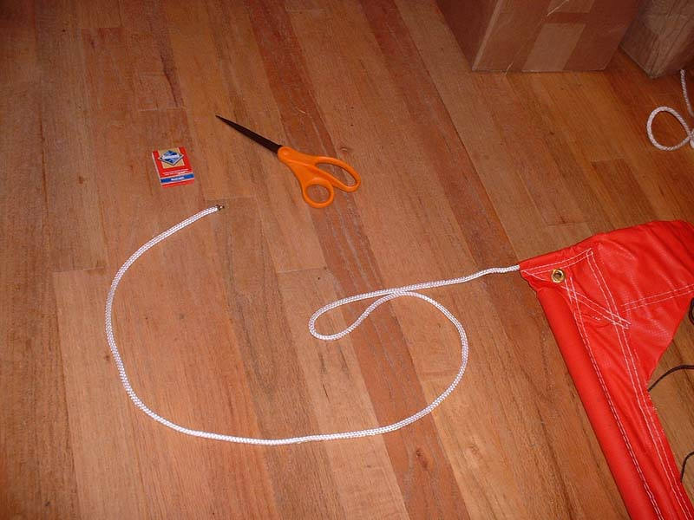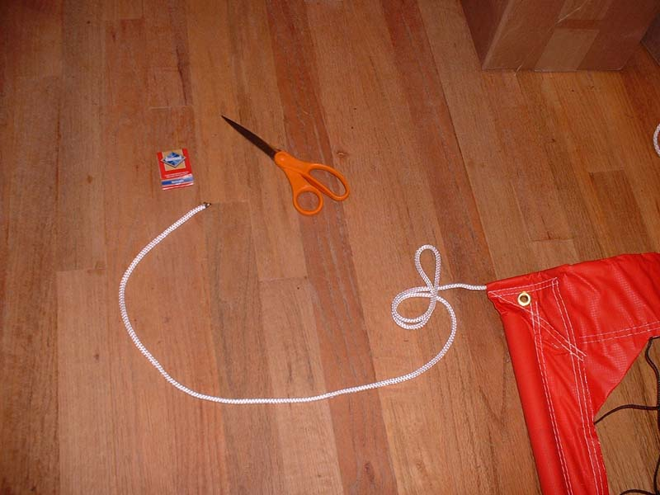

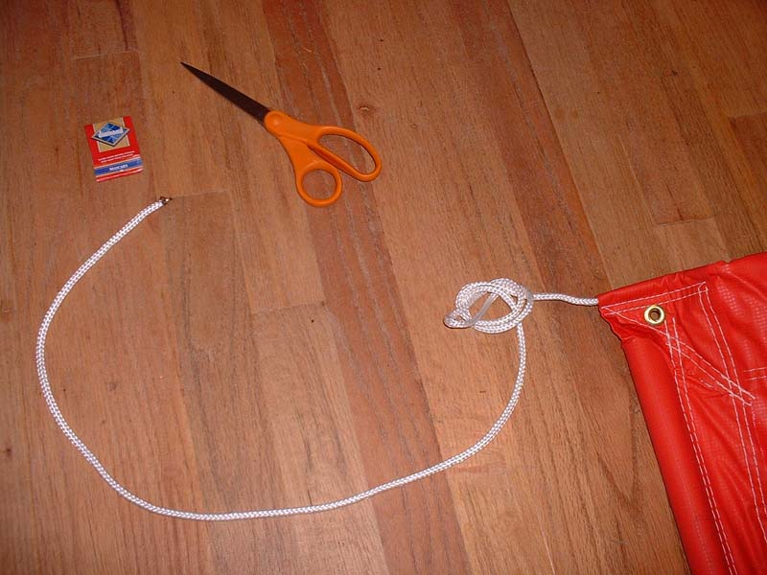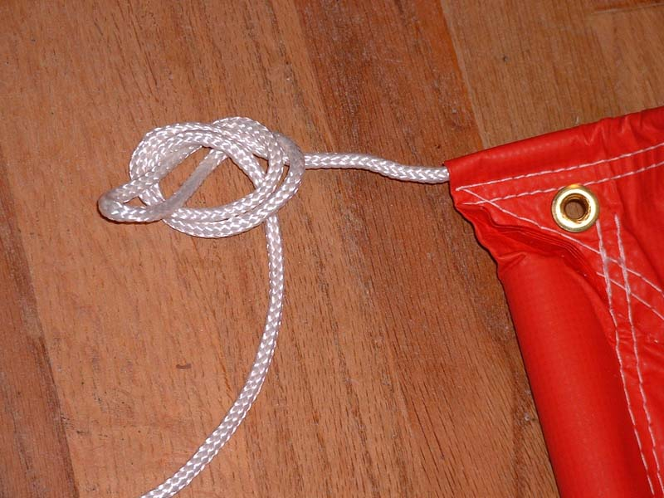

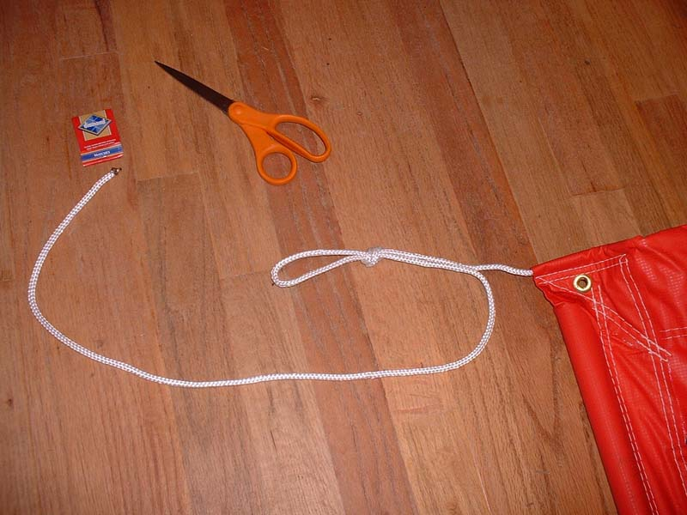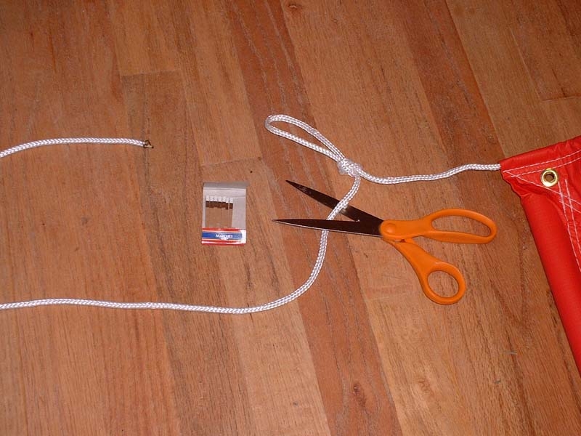

A United Volleyball Supply, LLC. Company
PH: 1-800-494-3933 FAX: 425-827-2230
727 Kirkland Ave.
Kirkland, WA 98033
1996-2007© VOLLEYBALLUSA.COM
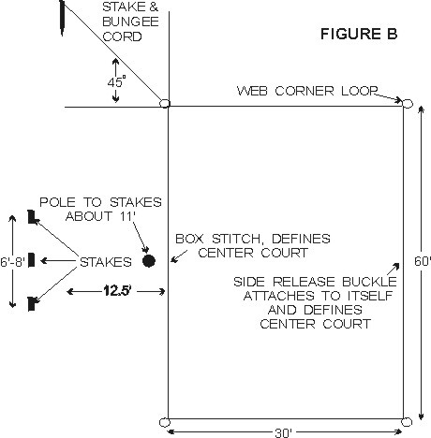
COURT LAYOUT
An ideal spot would be a flat grassy or sandy area free of holes or foreign objects with no limbs or wires overhead. Lay out web lines on the ground to form a rectangle, attach center court, side release buckles on one side of boundary. Other side of center court is marked by a box stitch, use tape if you prefer a larger mark. Attach hooks on bungee cord to each of the four large corner loops of the rectangle. Drive stakes into the ground at a 45-degree angle to the corner loop, or in sand bury them down about a foot at each corner. Do not pull too hard on bungee cord, just enough to get a straight line. Bungee cord will then stretch and snap back into place. Webbing stretches depending on how hard it is pulled on, so the size of your court can very. For set up on dry sand, you may need our Serious System sand kit.
CAUTION: WHEN REMOVING STAKES FROM THE GROUND ALWAYS GRAB BUNGEE CORD UP CLOSE TO STAKE AND PULL STRAIGHT UP OR DIG OUT OF SAND. ALWAYS USE BUNGEE CORD ATTACHED TO STAKE, TO ANCHOR CORNERS. DO NOT ANCHOR THE CORNERS WITH JUST A STAKE ALONE. USE PLASTIC ROLL UP RACK FOR BOUNDARY STORAGE. THE SUN WILL DETERIORATE THE WEBBING, DO NOT LEAVE OUTSIDE UNLESS IN USE AND NEVER LEAVE OUTSIDE OVERNIGHT, IT CAN BE A POTENTIAL HAZARD. WEBBING LINES ON THE GROUND MAY BE TRIPPED OVER, ALWAYS KEEP SMALL CHILDREN AWAY FROM PLAYING AREA, AND INFORM ALL OTHERS OF POTENTIAL HAZARD.

