Rec System Set-Up Instructions

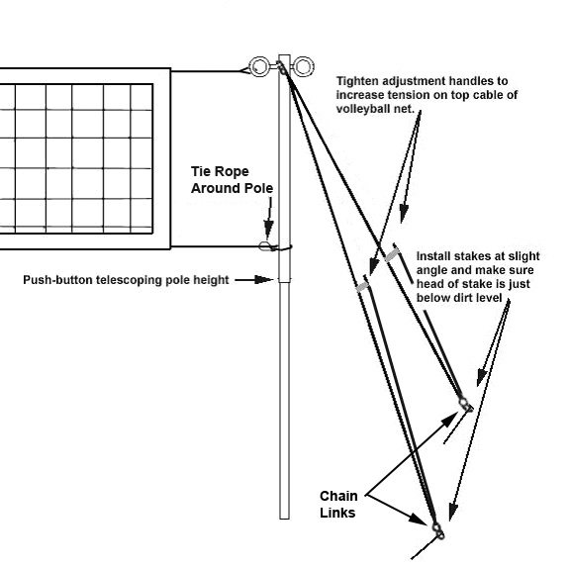
POLE AND NET SETUP
Attach rope guylines to upper eye bolt on each pole or wrap around the top of the pole. Then attach each nail stake through to the chain link at the end of guylines as shown above. Drive all stakes into the ground with a hammer, spacing stakes about 6-8 feet apart. CAUTION: STAKES MUST BE DRIVEN ALL THE WAY INTO GROUND WITH ONLY ROPE SHOWING ABOVE GROUND.
Attach top net rope to top eyebolt. Adjust pole by telescoping out to desired net height. (8’0 for men, 7’4” for women). Apply tension to top of net by pulling up on slide bars equally.
To tighten bottom net cable (rope or steel) attach onto mid-section of one pole and tighten the other side manually until bottom of net is tight.
Adjust bottom of pole so that the pole is standing straight up. A small bend in the pole is ok but don’t stress pole too much or the pole will not telescope properly.
After setting the system up the first time you can collapse the larger pole over the smaller below and roll the net up with the poles. This way when you set-up in the future you won’t have to re-connect the net to poles, only the guylines.
NOTE: Always try to keep the poles clean when telescoping them together to avoid the poles from binding together. Cleaning with a garden hose and water or submersing them in water can help in the event this occurs.
CAUTION: ALWAYS STAND ON BACKSIDE OF POLES WHEN TENSIONING YOUR NET! GUYLINE STAKES CAN COME LOOSE AND YOU DON’T WANT THE POLES TO FALL OVER INTO YOU OR SOMEONE ELSE!!! REMEMBER TO HAMMER ALL OF YOUR STAKES COMPLETELY INTO THE GROUND!! (GUYLINE AND CORNER BOUNDARY STAKES) NO PART OF THE STAKE SHOULD BE ABOVE THE GROUND!!!
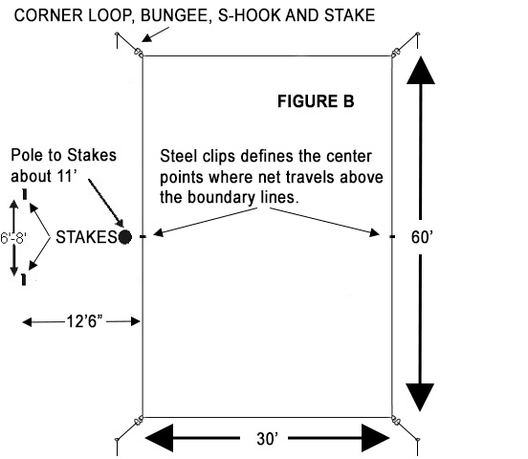
COURT LAYOUT: An ideal spot would be a flat grassy area free of holes or foreign objects with no limbs or wires overhead. Lay out the boundary lines on the ground to form a rectangle. It works best to have 4 people, one in each corner attach the s-hook on the end of the bungee cord connected to the stake and pull away from the corner in a 45 degree angle. Align the center point markers under the net and press the stakes into the grass or dirt by hand, hammer or shoe.
CAUTION: NEVER LEAVE YOUR VOLLEYBALL SYSTEM OUTSIDE OVERNIGHT. ROPE LINES ON THE GROUND MAY BE TRIPPED OVER, ALWAYS KEEP SMALL CHILDREN AWAY FROM PLAYING AREA, AND INFORM ALL OTHERS OF POTENTIAL HAZARD. THE SUN WILL DETERIORATE THE ROPE, DO NOT LEAVE OUTSIDE UNLESS IN USE. WHEN REMOVING NAIL STAKES FROM THE GROUND ALWAYS GRAB BUNGEE CORD UP CLOSE TO THE HEAD OF THE EYE BOLT AND PULL STRAIGHT UP OR DIG OUT OF SAND. BE CAREFUL AROUND BOUNDARY LINES & GUYLINES THAT MAYBE TRIPPED OVER!
1-800-494-3933 VolleyballUSA.com

