2" SS Set-Up Instructions

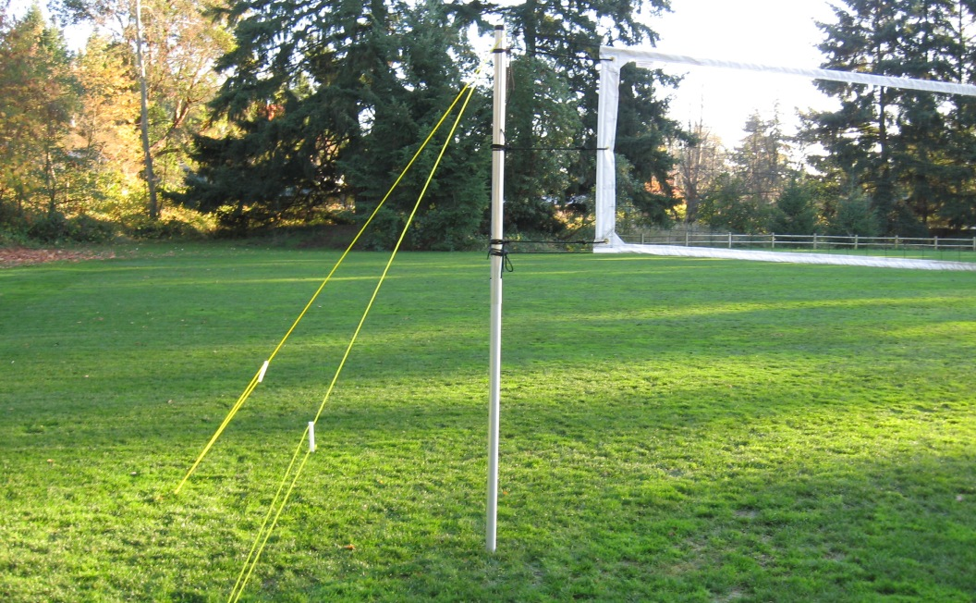

- First set your poles at one of the three height adjustment holes by using the push button to lock them into place.

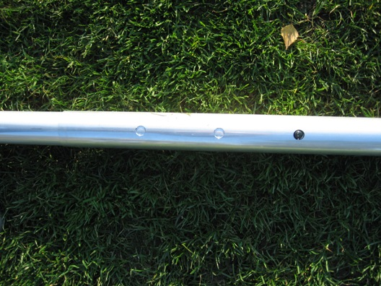

-Next, stretch your net out and start connecting the top cable of your net to the large eyebolts at the top of your poles. Tie them in several knots to prevent them coming loose.

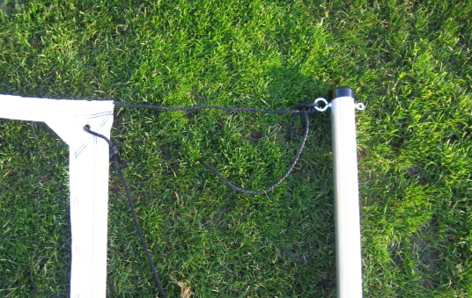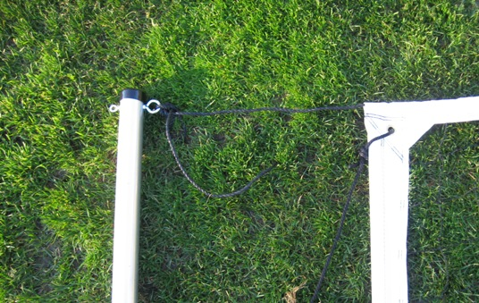
Now, take your yellow guy wires (pre assemble) and loop them over the top of your pole so that they rest on the large eyebolt and sit under the small eyebolt of your poles. Begin with one of the guy wires and stake it into the ground at a 45 degree angle while the poles lays on the ground.

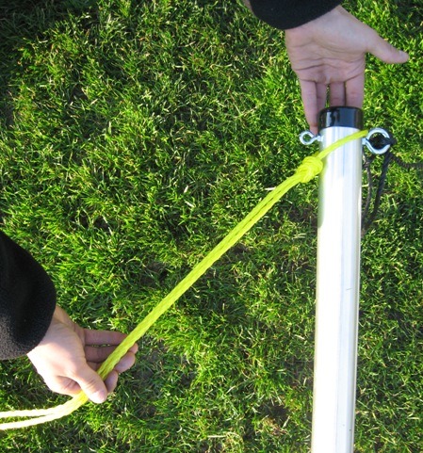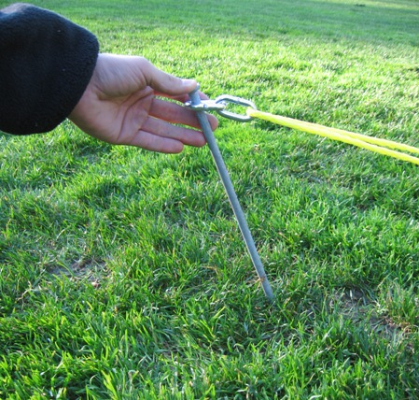

Be sure that the stake is sunk all the way in to the ground and that the head of the stake sits beneath ground level. After your first guy wire is staked down, stand your pole up and pull the other guy wire so that each wire is coming off the pole at 45 degrees in opposite directions. (see below right picture) Lean your pole towards the center of your court so when you tighten the guy wires they will pull the pole up straight. Proceed to the next pole and do the same with as the first leaving a healthy amount of sag in your net.

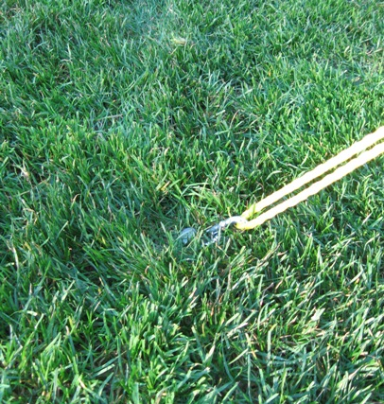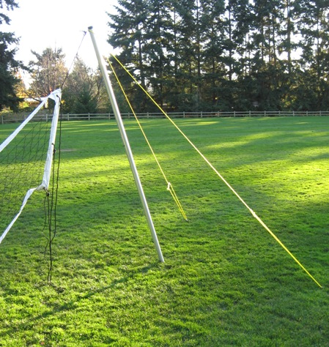

- Once your poles are set up, pull the white guy wire handle up and slide them all equally to get full tension on your net. You may need to re-adjust the angle of your pole. When under full tension, lift the pole just enough to slide it into place.

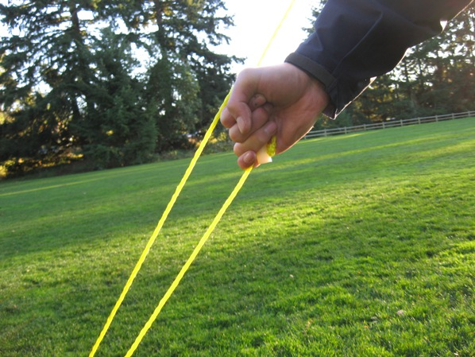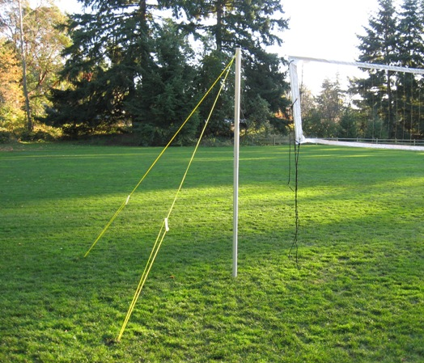

- Take the bottom cable of your net and loop it around the pole, pulling it as tight as you can, and tie it back to itself.

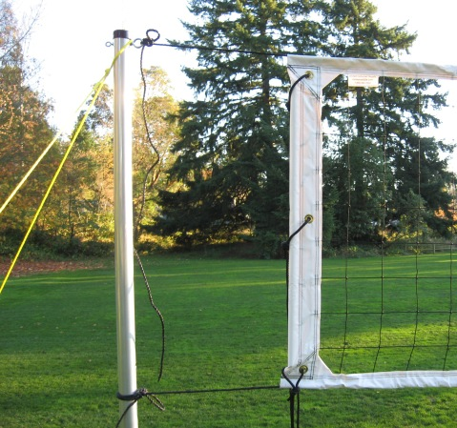

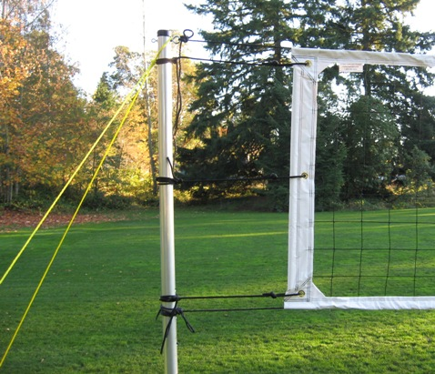

- Finish by tying the optional black tension ropes on the sides of your net for extra tension and to center the net on your court. Tie them like you did to the bottom cable of your net.

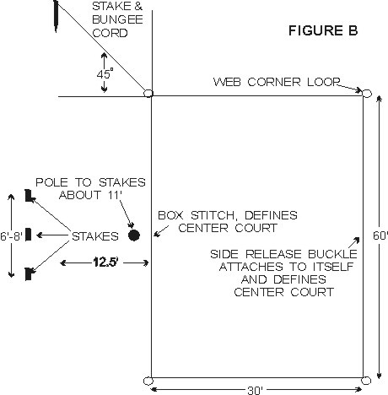
COURT LAYOUT
An ideal spot would be a flat grassy or sandy area free of holes or foreign objects with no limbs or wires overhead. Lay out web lines on the ground to form a rectangle, attach center court, side release buckles on one side of boundary. Other side of center court is marked by a box stitch, use tape if you prefer a larger mark. Attach hooks on bungee cord to each of the four large corner loops of the rectangle. Drive stakes into the ground at a 45-degree angle to the corner loop, or in sand bury them down about a foot at each corner. Do not pull too hard on bungee cord, just enough to get a straight line. Bungee cord will then stretch and snap back into place. Webbing stretches depending on how hard it is pulled on, so the size of your court can very. For set up on dry sand, you may need our #1026 sand kit.
CAUTION: WHEN REMOVING STAKES FROM THE GROUND ALWAYS GRAB BUNGEE CORD UP CLOSE TO STAKE AND PULL STRAIGHT UP OR DIG OUT OF SAND. ALWAYS USE BUNGEE CORD ATTACHED TO STAKE, TO ANCHOR CORNERS. DO NOT ANCHOR THE CORNERS WITH JUST A STAKE ALONE. USE PLASTIC ROLL UP RACK FOR BOUNDARY STORAGE. THE SUN WILL DETERIORATE THE WEBBING, DO NOT LEAVE OUTSIDE UNLESS IN USE AND NEVER LEAVE OUTSIDE OVERNIGHT, IT CAN BE A POTENTIAL HAZARD. WEBBING LINES ON THE GROUND MAY BE TRIPPED OVER, ALWAYS KEEP SMALL CHILDREN AWAY FROM PLAYING AREA, AND INFORM ALL OTHERS OF POTENTIAL HAZARD.

